//Program 3.13

#include <iostream>

#include <iomanip>

using namespace std;

int main(){

cout << "\n\t Multiplication Tables";

cout << "\n_____________________________________\n\n";

//print multiplication table for 1 to 2

for (int n = 1; n <= 2; n++)

{

for (int j = 1; j <= 10; j++)

{

cout << setw(4) << j * 1;

}

cout << endl;

}

cout << "\nEnd of Program";

return 0;

}

1. What is the output of the program?

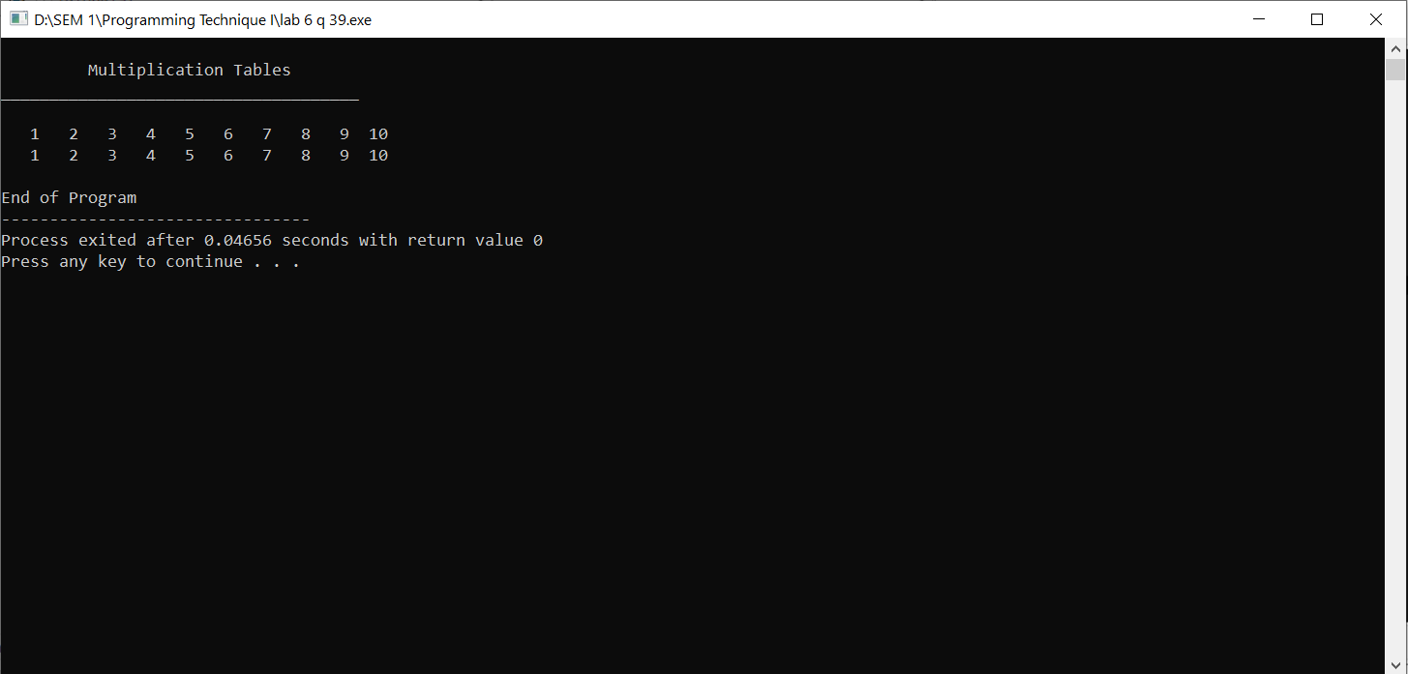

1. Program 3.13 is supposed to produce the same output as Program 3.12, but the output is different. Identify the problem and fix it.

The inner loop’s calculation multiply the column variable (j) by 1 instead of multiplying by row variable (n)

1. Identify the outer loop. How many times will the body of the outer loop execute? What does each outer loop represent? What exact code determine the number of times the outer loop will execute?

Line 10. Outer loop will execute twice. Outer loop represent row.

for (int n = 1; n <= 2; n++)

1. Identify the inner loop, how many times will the body of the inner loop execute? What does each outer inner represent? What exact code determine the number of times the inner loop will execute?

Line 12. Inner loop will execute 10 times twice. Inner loop represent column.

for (int j = 1; j <= 10; j++)